sample email to share with employees

**Subject:** Place Items Directly into Your Recycling Bin – No Plastic Bags, Please!

Team,

As you’ve probably noticed, we’ve implemented a handful of improvements to our recycling program. Recycling bins are located DESCRIBE LOCATIONS. And, we’ve placed a [poster](https://www.wm.com/content/dam/wm/documents/RecyclingResources/Posters-Guides-Tools/Poster-What-To-Recycle-At-Work.pdf) near or above each bin that shows exactly what materials can be recycled.

One of the biggest changes that we’ve made is eliminating plastic bags or liners from all recycling bins. As we’ve recently learned, plastic bags of all types are NOT accepted in our recycling program. Additionally, recyclable materials should always be clean and dry and placed directly in the recycling container loose – not in plastic bags.

## Why Does it Matter?

When our recyclables arrive at the local plant, they go through an automated sorting process. Recyclables must be loose (not in a bag) in order to make their way through the sorting equipment. Plastic bags wreak havoc at the plant; they become wrapped around sorting equipment. When this happens, all equipment must be shut down so that workers can climb into the machinery and cut plastic bags out of gears and screens. This poses a serious safety risk for workers and makes recycling inefficient and costly.

## How You Can Help?

Keep plastic bags out of the recycling and do not bag recyclables. (As a side note, the same rules regarding plastic bags apply at home too!) And make sure all your recyclables are clean and dry – empty any food or liquids before recycling. If you’re interested in learning more, visit [Recycling Resources for Business](https://www.wm.com/us/en/inside-wm/recycle-right/recycling-resources#business)and check out this short video on business recycling: <https://youtu.be/SQfp_l7aKdY>.

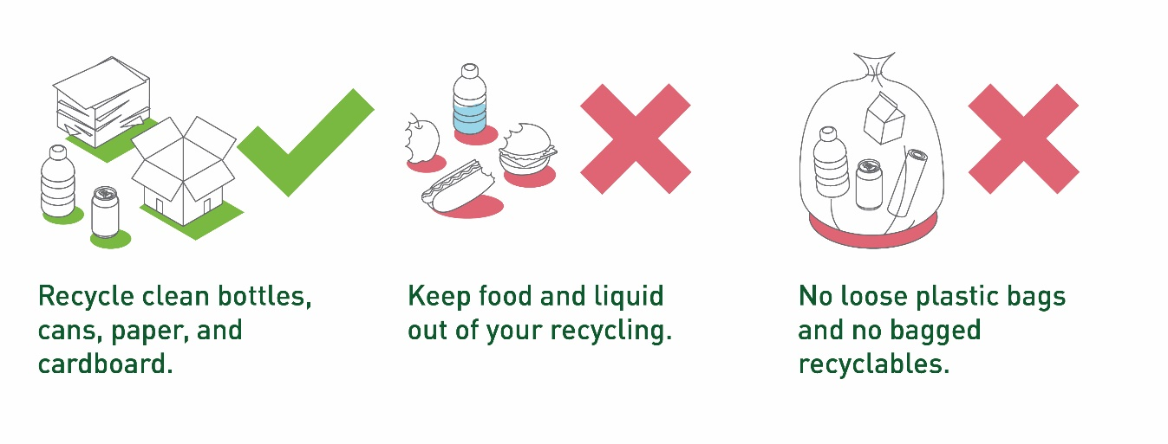I appreciate everyone’s help as we work to improve the quality of our recycling program. If you have any additional ideas for improvement, please let me know!

* NAME