Dear Residents,
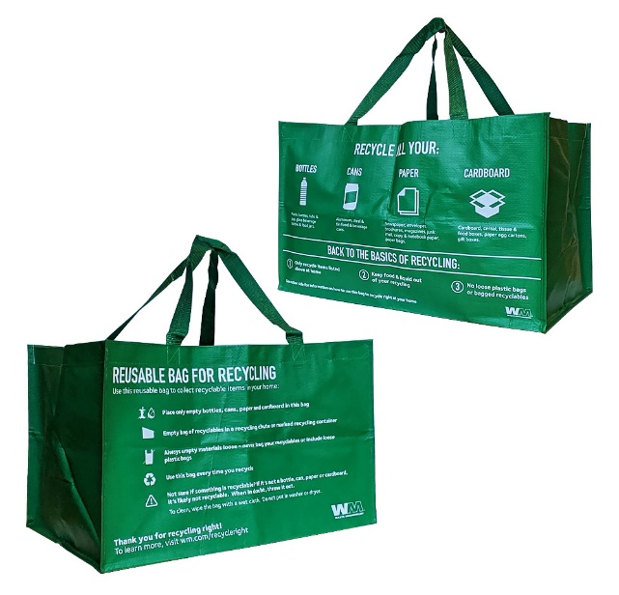
We take great pride in being good stewards of our environment and providing recycling services
that make it easy and convenient for you to recycle at home.
We are pleased to announce that on XX, we will be providing a Recycle Right Reusable Tote Bag for each tenant to collect and carry recyclables to the community recycling container. Inside the bag will be a Recycle Right poster that shows you what materials are acceptable to recycle that you can post where you collect your recyclables. (Change language according to reusable bag distribution strategy.)
The reusable tote bags also list the materials that are accepted in our recycling bins. If an item is not listed on the reusable bag or the poster, please do not put it in the recycling bin. Recycling non-acceptable materials like plastic bags or bagged recyclables can ruin an entire load of good recyclables and result in increased recycling costs for our community. To order additional Recycle Right tote bags, visit wmgetgear.wm.com
Remember these three basic rules each time you recycle: 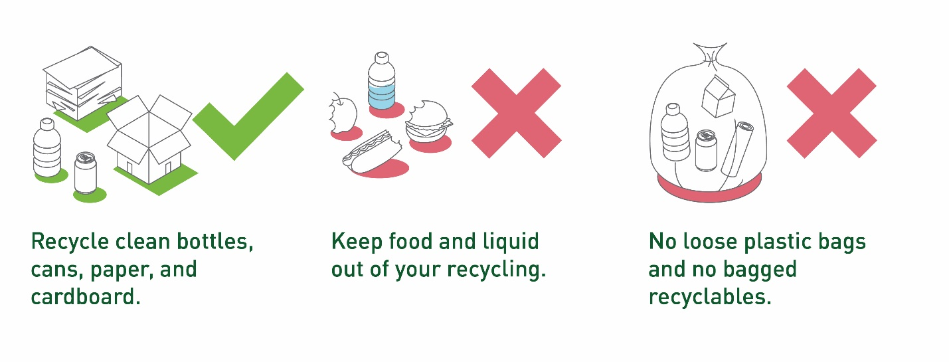Recycling Tips:
- With plastics, judge by the shape of the container. Recycle bottles, tubs, and jugs. Lids should stay on.
- Please empty and breakdown cardboard boxes.
- When in doubt, throw it out.
Thank you for recycling! For more information and resources you can download, visit wm.com/recycleright

Sincerely,
COMPLEX CONTACT INFO HERE

